Galloping Myopia & Digital eye strain-12th Oct 2017

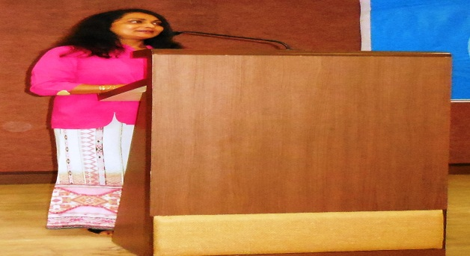

Expert Lecture on Myopia

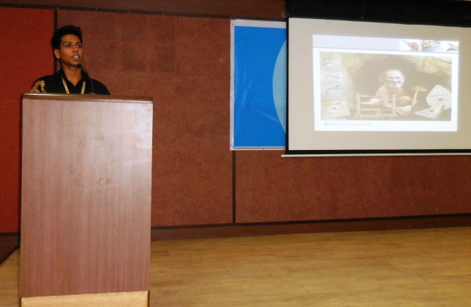

Lecture on Digital eye strain by CIPS faculty

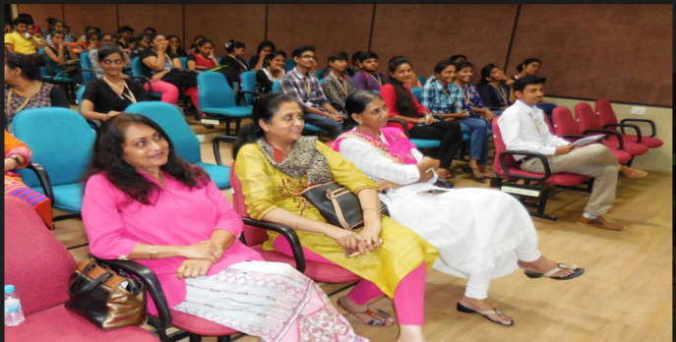

Participants attending an Event